Work Order No. W-00685 Array Description
Dario Ringach Array No. 01Feb1A-1
Dept. of Neurobiology and Psychology 10 × 10, 1.0 mm array
University of California, Los Angeles Parylene insulation
Los Angeles, CA 90095-1563 6.7 cm, 1 mil Au-plated Cu wire PU4025
10.7 cm, 3 mil, 20% Ir-Pt Referenc/Ground wires

96-Electrode Array

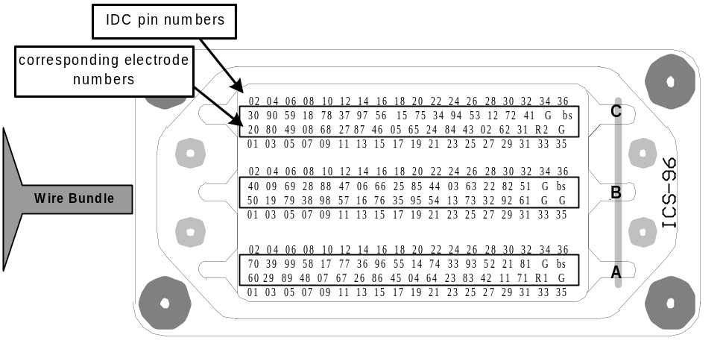
 |  |  |  |  |  |  |  |  |  |  |  | 92 | 93 | 94 | 95 | 96 | 97 | 98 | 99
 |  |  |  |  |  |  |  |  |  |  | 81 | 82 | 83 | 84 | 85 | 86 | 87 | 88 | 89 | 90
 |  |  |  |  |  |  |  |  |  |  | 71 | 72 | 73 | 74 | 75 | 76 | 77 | 78 | 79 | 80
 |  |  |  |  |  |  |  |  |  |  | 61 | 62 | 63 | 64 | 65 | 66 | 67 | 68 | 69 | 70
 |  |  |  |  |  |  |  |  |  |  | 51 | 52 | 53 | 54 | 55 | 56 | 57 | 58 | 59 | 60
 |  |  |  |  |  |  |  |  |  |  | 41 | 42 | 43 | 44 | 45 | 46 | 47 | 48 | 49 | 50
 |  |  |  |  |  |  |  |  |  |  | 31 | 32 | 33 | 34 | 35 | 36 | 37 | 38 | 39 | 40
 |  |  |  |  |  |  |  |  |  |  | 21 | 22 | 23 | 24 | 25 | 26 | 27 | 28 | 29 | 30
 |  |  |  |  |  |  |  |  |  |  | 11 | 12 | 13 | 14 | 15 | 16 | 17 | 18 | 19 | 20
 |  |  |  |  |  |  |  |  |  |  |  | 2 | 3 | 4 | 5 | 6 | 7 | 8 | 9
Electrode Numbers ICS Connector

Viewed from the bond pad side

- There is one reference electrode wire, shown as R1. The ends of the reference wires are un-insulated. If the end of a reference wire is cut off, then approximately 2 to 3mm of the tip must be de-insulated with a clean blue flame before implantation.
- Grounded pins on the connectors are shown as G and the bus is shown as bs.
- The electrode impedance is measured with a 100 nA peak-to-peak, 1kHz sine wave current. NOTE: Impedance values are not absolute.

Work Order No. W-00685 Array Description
Dario Ringach Array No. 01Feb1A-9
Dept. of Neurobiology and Psychology 10 × 10, 1.0 mm array
University of California, Los Angeles Parylene insulation
Los Angeles, CA 90095-1563 6.7 cm, 1 mil Au-plated Cu wire PU4025
10.7 cm, 3 mil, 20% Ir-Pt Referenc/Ground wires

96-Electrode Array

 |  |  |  |  |  |  |  |  |  |  |  | 92 | 93 | 94 | 95 | 96 | 97 | 98 | 99
 |  |  |  |  |  |  |  |  |  |  | 81 | 82 | 83 | 84 | 85 | 86 | 87 | 88 | 89 | 90
 |  |  |  |  |  |  |  |  |  |  | 71 | 72 | 73 | 74 | 75 | 76 | 77 | 78 | 79 | 80
 |  |  |  |  |  |  |  |  |  |  | 61 | 62 | 63 | 64 | 65 | 66 | 67 | 68 | 69 | 70
 |  |  |  |  |  |  |  |  |  |  | 51 | 52 | 53 | 54 | 55 | 56 | 57 | 58 | 59 | 60
 |  |  |  |  |  |  |  |  |  |  | 41 | 42 | 43 | 44 | 45 | 46 | 47 | 48 | 49 | 50
 |  |  |  |  |  |  |  |  |  |  | 31 | 32 | 33 | 34 | 35 | 36 | 37 | 38 | 39 | 40
 |  |  |  |  |  |  |  |  |  |  | 21 | 22 | 23 | 24 | 25 | 26 | 27 | 28 | 29 | 30
 |  |  |  |  |  |  |  |  |  |  | 11 | 12 | 13 | 14 | 15 | 16 | 17 | 18 | 19 | 20
 |  |  |  |  |  |  |  |  |  |  |  | 2 | 3 | 4 | 5 | 6 | 7 | 8 | 9
Electrode Numbers ICS Connector

Viewed from the bond pad side

- There is one reference electrode wire, shown as R1. The ends of the reference wires are un-insulated. If the end of a reference wire is cut off, then approximately 2 to 3mm of the tip must be de-insulated with a clean blue flame before implantation.
- Grounded pins on the connectors are shown as G and the bus is shown as bs.
- The electrode impedance is measured with a 100 nA peak-to-peak, 1kHz sine wave current. NOTE: Impedance values are not absolute.

